1. Label the graph in Figure 1 with respect to the three phases of the business cycle and the cycle turning points.

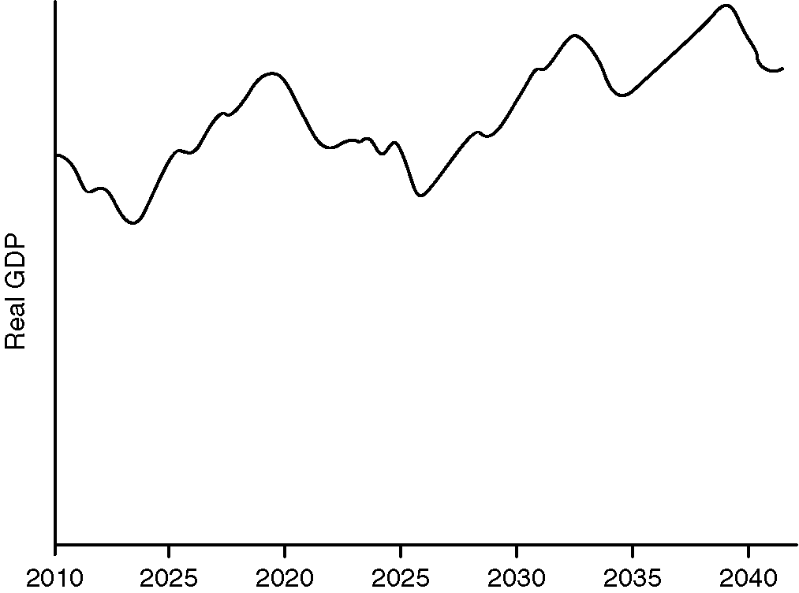

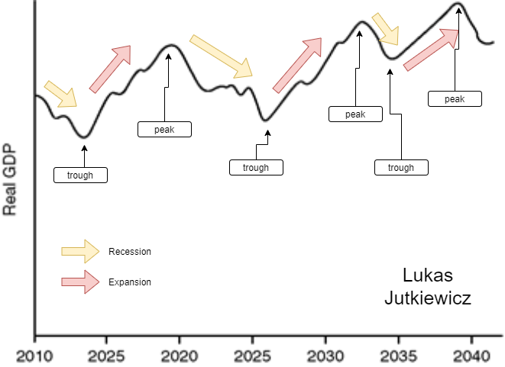**Figure 1**

**Figure 2**

1. 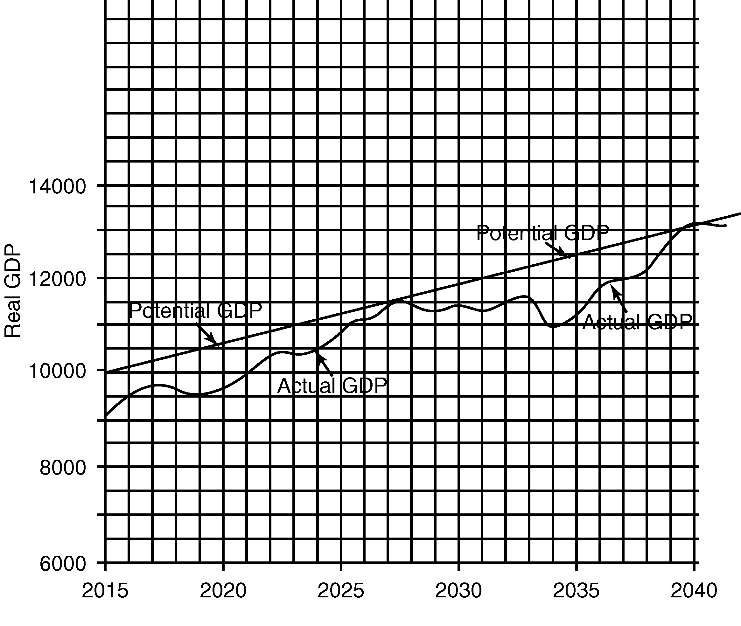How much was the GDP gap in (a) 2020? (b) 2034? and (c) 2040?

**Answer:**

* 1. GDP gap (2020) ~1000 of something
  2. GDP gap (2034) ~1500 of something
  3. GDP gap (2020) ~0 of something

1. If 4 million people are collecting unemployment insurance benefits, 12 million people are officially unemployed, 113 million people are employed, and there are 2 million discouraged workers,

**Answer:**

(a) How many people are in the labor force?

12+113+2=127 million

(b) What is the unemployment rate?

(12/127)*100 = 9.44%

1. If the official unemployment rate is 8%, how much is the cyclical rate of unemployment?

**How can I calculate this with out natural rate of unemployment given???**

**Answer (assuming natural rate of unemployment is 4.5%):**

8% - 4.5% = 3.5%

1. If the CPI rose is 234.1, by what percentage did the price level rise since the base year?

**Answer:**

234.1%

1. A goldsmith has 2000 gold coins in his safe and 2000 receipts circulating.

(a) How much are his outstanding loans and what is his reserve ratio?

(b) the goldsmith lends out 200 of his coins. What is his reserve ratio?

**Answer:**

a.

outstanding loans = 0

assuming reserve requirement is 10% (like in U.S.)

reserve ratio = 20 gold coins

b.

assuming reserve requirement is 10% (like in U.S.)

reserve ratio = 18 gold coins

1. If GDP is $6 trillion, the multiplier is 9, and I rises by 20, what is the new level of GDP?

**Answer (Assuming I is in trillions):**

6 + 9 * 20 = $186 trillion

1. If GDP is 7500, the MPC is .8, and G falls by 20, what is the new level of GDP?

**Answer:**

Multiplier = 1 / (1 – 0.8) = 5

New GDP = 7500 + (-20 * 5) = 7400

**Figure 3**

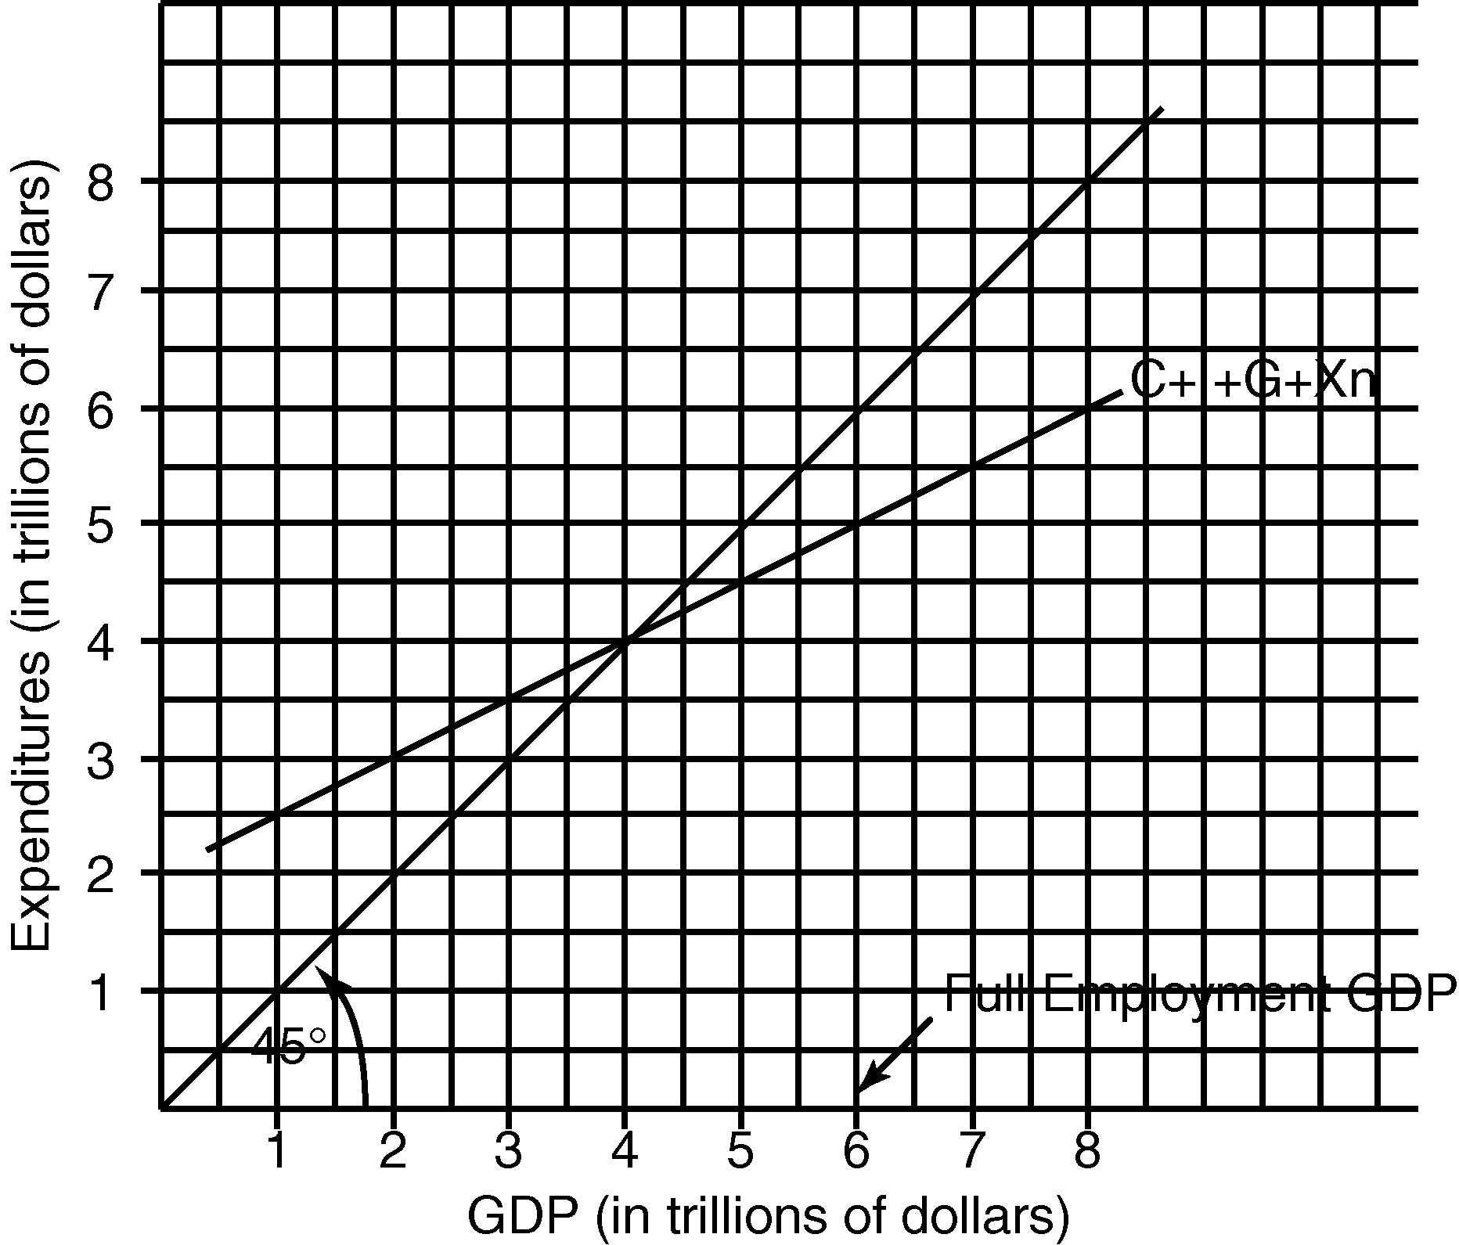Use this graph to answer the following questions:

1. Is this an inflationary gap or a deflationary gap? How much is it?

**Deflationary gap: $2 Trillion**

1. What two fiscal policy measures do you recommend to remove it?

**Increase spending and decrease taxes (expansionary fiscal policy) to stimulate aggregate demand.**

1. The following table gives statistics on the labor force and total employment during year 1 and year 5. Make the computations necessary to complete the table. (Numbers of persons are in thousands.)

|  |  |  |
| --- | --- | --- |
|  | **Year 1** | **Year 5** |
| Labor force | 84,889 | 95,453 |
| Employed | 80,796 | 87.524 |
| Unemployed | __4093___ | __7929___ |
| Unemployment rate | __4.8%___ | __8.3%___ |

1. The total demand for money is equal to the transactions plus the asset demand for money.
   1. Assume each dollar held for transactions purposes is spent (on the average) four times per year to buy final goods and services.
      1. This means that transactions demand for money will be equal to (what fraction or percent) ___25%__________ of the nominal GDP, and,
      2. if the nominal GDP is $2000 billion, the transactions demand will be $_________500______ billion.
   2. The following table shows the number of dollars demanded for asset purposes at each rate of interest. Given the transactions demand for money in (*a*), complete the table.

|  |  |  |  |
| --- | --- | --- | --- |
|  | *Amount of money demanded*  *(billions)* | | |
| **Interest**  **rate** | **For asset**  **purposes** | **Total** | |
| 16% | $ 20 | $_520____ | |
| 14 | 40 | __540___ | |
| 12 | 60 | ___560__ | |
| 10 | 80 | ___580__ |
| 8 | 100 | ___600__ | |
| 6 | 120 | ___620__ | |
| 4 | 140 | ___640__ | |

* 1. Assume the money supply (***Sm***) is $580 billion. The equilibrium rate of interest is __10___%.
  2. Should the money supply
     1. increase to $600 billion, the equilibrium interest rate would (rise, fall) ___fall_____ to __8__%.
     2. decrease to $540 billion, the equilibrium interest rate would _____rise___ to __14___%.
  3. If the nominal GDP

increased by $80 billion, the total demand for money would (increase, decrease) ______increse_________ by $____20___ billion at each rate of interest and the equilibrium rate of interest would (rise, fall) _____rise_____ by __2___%.

1. The following table has three aggregate demand schedules.

|  |  |  |  |
| --- | --- | --- | --- |
| **Price level** | ***Real domestic output demanded*** | | |
|  | | |
| **(1)** | **(2)** | **(3)** | **(4)** |
| 250 | 1400 | 1900 | 500 |
| 225 | 1500 | 2000 | 600 |
| 200 | 1600 | 2100 | 700 |
| 175 | 1700 | 2200 | 800 |
| 150 | 1800 | 2300 | 900 |
| 125 | 1900 | 2400 | 1000 |
| 100 | 2000 | 2500 | 1100 |

* + 1. On the graph, plot the aggregate demand curve shown in columns 1 and 2; label this curve **AD1**. At this level of aggregate demand, the equilibrium real domestic output is __1700_____ and the equilibrium price level is ___175_______.
    2. On the same graph, plot the aggregate demand curve shown in columns 1 and 3; label this curve **AD2**. The equilibrium real domestic output is __2000_____ and the equilibrium price level is ____225_______.